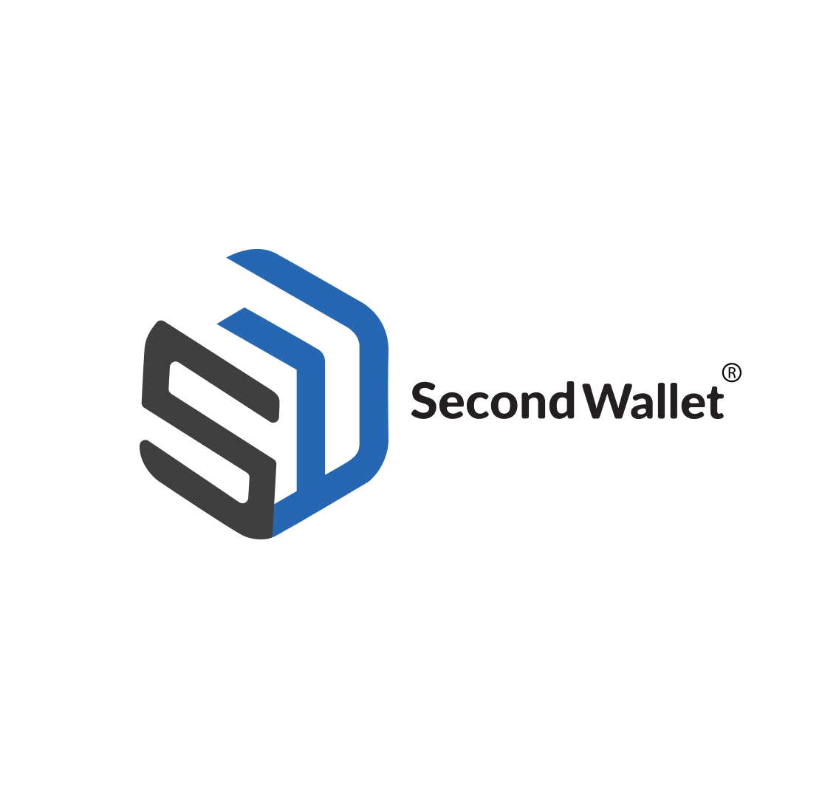

Second Wallet Broche Review

**WHAT IS SECOND WALLET?**

Second Wallet is an innovation into the financial technology space to provide access to financial services.

We are a full digital consumer lending platform that gives access to credit with no paperwork, simple payment solutions, and attractive interest on loans.

With SECOND WALLET, you can take care of your urgent needs anywhere, anytime.

**WHO ARE WE? (ABOUT US)**

We are a financial technology company to drive financial inclusion by providing access to short and medium-term loans thereby enabling people to borrow and transact.

Our vision is to make finance easy and accessible through technology to people across Nigeria and Africa as a whole.

We are driven towards making funds available 24hours a day, 7 days a week with our quick application process that lets you know your status within minutes.

**OUR VISION:**

Our vision at Second Wallet is to deliver World Class financial services to the digital generation unhindered.

**OUR MISSION:**

Our mission is to eliminate hardship in accessing financial services through the use of technology. Our dedication is to ensure that people and businesses thrive with access to credit facilities in the best possible way, within the best possible time.

**OUR VALUES:** Our values are embedded in the acronym **F.A.S.T.**

**FLEXIBILITY:** We are dedicated to making internal changes in response to the changing environment to meet up with current needs, as quickly as possible. Our goal is to provide easy use of all our platforms in a very flexible manner and to provide our services most flexibly. This is why we have an INSTALMENT PAYMENT plan for loans obtained, where customers can choose a convenient period to repay their loans.

**ACCESSIBILITY:** Our drive is towards making funds available anywhere, anytime.

**SPEED:** We are committed to serving as many customers as possible within the shortest time.

**TRANSPARENCY & INTEGRITY:** There are no hidden charges, Consumers know just how much they are to pay back, the period, and any other information attached to their credit.Quality, consistency, and customer satisfaction is our watchword and we will not compromise our values.

**PROBLEM IDENTIFICATION**

We all have that one time in our lives that we would need money urgently maybe for some personal use or for some other things that come our way. Getting a quick loan might be the fastest way through your second wallet, us.

Today, technology has opened the doors to financial inclusion in advanced countries in which an average man has access to funding to sponsor the basic needs of life, grow his business and even engage oneself in some basic luxuries.

Third world countries are still lagging and the rigors of accessing credit are unpalatable as compared to the advanced countries. Unending queues, difficult payment terms, unfair repayment rates, and the use of collaterals have continued to refrain access to funding, thereby increasing the spread of poverty and financial exclusion.

In recent years, there has been a massive rise in the advent of Financial Technology companies that provide easy access to loans, but the problem remains that consumers find it difficult to make repayments due to the huge interest rate and a one-off payment requirement.

**OUR SOLUTION**

YES! We are bringing ease by providing a SECOND WALLET to meet your needs in a very easy and flexible way.

Our clients need to provide just a little information to get started. Our state of the art mobile application provides a personalized platform for each user, thereby facilitating ease for future use.

We are also introducing a feature that will make repayment a lot easier and remove the burden of an all at once payment which is called the INSTALMENT PAYMENT PLAN.

A customer can borrow funds and repay in installments over their loan period, Amazing right?

We are here to provide flexibility like no other, quicker access to funding, and a no-match user-friendly experience.

**FEATURES OF SECOND WALLET**

**QUICK LOANS**: Download the application, apply, and get instantly notified if you qualify or not.

**FLEXIBILITY:** Our repayment structure is flexible which means you don’t have to break a bank to pay back.

**AMAZING RATES:**  We have the most competitive interest rate in the market which makes us a top choice.

**SECURITY:** All the data provided are encrypted and protected and never released to third parties. Strict policies are in place that ensure our methods are properly communicated and customer data is always protected.

**EASY TO USE:** Our platform is specially built for you; it is user friendly, stress-free, and easy to navigate.

**7*24 HOUR SERVICE:** Our service runs 7(seven) days a week, 24 hours a day.

**QUICK RESPONSE**: The mobile app has an unlimited bandwidth that makes the application very responsive.

**QUICK TRANSACTION:** Loan approval within a short period.

**100% TRANSPARENCY**: SECOND WALLET exists to put smiles on the faces of our customers and eliminate all forms of hardship in accessing short term loans. It is our goal to ensure a very transparent process in determining who is eligible, how much they are eligible for, and what payment plans they are eligible to get. There are also clear breakdowns of the total amount of repayment.

**THE MOBILE APPLICATION.**

In a bid to match up with the digital age and provide world-class financial services unhindered, SECOND WALLET has developed a mobile application. The SECONDWALLET mobile application allows users to manage all transactions right from their mobile devices.

**FEATURES OF THE MOBILE APPLICATION.**

**1. PUSH NOTIFICATIONS:** This feature enables our customers to have first-hand knowledge of all our activities. Information is communicated directly to them on the application.

**2. ONLINE SUPPORT:** We have an online support team that is readily available to talk to the customers and extract information about their loans. They attend to the need of customers virtually, thereby enabling an amazing user experience.

**3.**

**INTEGRATED CLOUD STORAGE:** User's privacy and data are of utmost importance to us at SECOND WALLET, and it is our responsibility to keep it secure and confidential. This is done by integrating cloud storage on the app.

**4. AUTOMATIC LOAN CALCULATIONS:** Customers would not need to worry about how much they would be paying or the period, this is computed automatically by a system embedded into the mobile application.

**5. USER ACCOUNT:** Each user's account is personalized to reflect their names, profile, and transaction details.

**SECOND WALLET LOAN CATEGORIES OR PRODUCTS**

**Retail Private Sector:** We provide funding to salary earners from private sector organizations through our mobile application.

**Retail Public Sector:** We also provide lending to civil servants from both Federal and State government parastatals.

**MARKET WOMEN SCHEME:** Our market women scheme is designed to assist traders, artisans, etc get access to funding to augment their working capital needs.

**ASSET FINANCING:** You need to purchase an item and you do not have enough cash? No worries, we are available to help finance that funding gap, while you repay your outstanding balance to us.

**SMALL AND MEDIUM-SIZED ENTERPRISES:** The major drivers of any economy are SME's. We have designed easy access and cheap SME products to aid funding to small and medium scale entrepreneurs.

**PARTNERS**

**JIDE ALABI**

Chief Executive Officer (C.E.O)

Jide Alabi serves as the CEO of Second Wallet. He is a seasoned business development manager with about ten years of experience in the financial services industry.

He worked at Guaranty Trust bank for about ten years, majorly in their retail, small and medium enterprises division.

He holds a master's degree from the University of Ilorin and A Bachelor of Science Degree from Bowen University in Osun State.

E-mail: [Jidealabi@secondwalletng.com](mailto:Jidealabi@secondwalletng.com)

**OLADAYO AREOLA**

Managing Director

Oladayo Areola Is a well seasoned financial services officer with over eleven years of work experience in the banking sector. Oladayo is the Managing director of Second Wallet.

He holds a Bachelor of Science degree in Business Administration from Kwara State University, Malete, Kwara State.

He was once a transaction officer in Guaranty Trust Bank Plc before setting up Second Wallet Nig LTD. He has attended various training programs in banking which includes excellent customer service delivery, consumer lending, and commercial loan to small businesses.

Email address: [oladayoareola@secondwalletng.com](mailto:oladayoareola@secondwalletng.com)

**CONTACT US:**

**OFFICE ADDRESS**

Testimony House (Federal forestry). Offa Road, G.R.A., P.O.Box 4824, Ilorin, Kwara State, Nigeria.